PIZZA SALES SQL (MySQL) QUERIES

**Data Source** : Youtube Channel “Data Tutorial”

A. KPI’s

**1. Total Revenue:**

Select Cast(sum(total_price) as decimal(10,2)) as Total_Revenue from pizza_sales15;

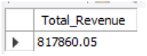

**2. Average Order Value:**

Select Cast(Sum(total_price)/count(distinct order_id) as decimal (10,2)) as Avg_order_value from pizza_sales15;

**3. Total Pizza Sold**

Select Sum(quantity) as Total_pizza_sold from pizza_sales15;

**4. Total Orders**

Select count(distinct order_id) as Total_orders from pizza_sales15;

**5. Average Pizzas Per Orders**

Select Cast((sum(quantity)/Count(distinct order_id)) as decimal(10,2)) as Avg_Pizzas_per_order from pizza_sales15;

**B. Daily Trend for Total Orders**

Select dayname (str_to_date (order_date,'%m/%d/%Y')) as order_day,

count(distinct order_id) as total_orders from pizza_sales15

group by order_day;

**C. Monthly Trend for Total Orders**

Select monthname(str_to_date (order_date, '%m/%d/%Y')) as Month_name,

count(distinct order_id) as total_orders from pizza_sales15

group by Month_name;

**D. Percentage of Sales by Pizza Category**

Select pizza_category, Cast(sum(total_price) as decimal (10,2)) as total_revenue,

Cast(sum(total_price)*100/(select sum(total_price) from pizza_sales15)

as decimal(10,2)) as Percentage from pizza_sales15

group by pizza_category

order by Percentage desc;

**E. Percentage of Sales by Pizza Size**

Select pizza_size, cast(sum(total_price) as decimal(10,2)) as total_revenue,

cast(sum(total_price)*100/(select sum(total_price) from pizza_sales15)

as decimal (10,2)) as Percentage from pizza_sales15

group by pizza_size

order by Percentage desc;

**F. Total Pizzas Sold by Pizza Category**

Select pizza_category, sum(quantity) from pizza_sales15

group by pizza_category;

**G. Top 5 Pizza by Revenue**

Select pizza_name, cast(sum(total_price) as decimal (10,2))as total_revenue

from pizza_sales15

group by pizza_name

order by total_revenue desc

limit 5;

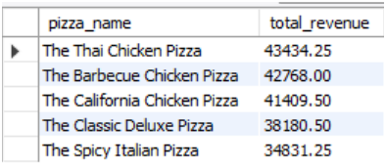

**H. Bottom 5 Pizza by Revenue**

Select pizza_name, Cast(sum(total_price) as decimal(10,2)) as total_revenue

from pizza_sales15

group by pizza_name

Order by total_revenue asc

Limit 5;

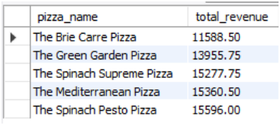

**I. Top 5 Pizza by Quantity**

Select pizza_name, sum(quantity) as Total_Pizza_Sold from pizza_sales15

group by pizza_name

order by Total_Pizza_Sold desc

limit 5;

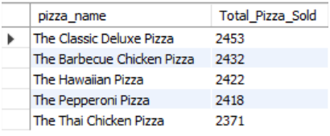

**J. Bottom 5 Pizza by Quantity**

Select pizza_name, sum(quantity) as Total_Pizza_Sold

from pizza_sales15

group by pizza_name

order by Total_Pizza_Sold

limit 5;

**K. Top 5 Pizza by Total Orders**

Select pizza_name, count(distinct order_id) as Total_order

from pizza_sales15

group by pizza_name

order by Total_order desc

limit 5;

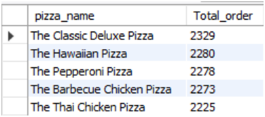

**L. Bottom 5 Pizza by Total Orders**

Select pizza_name, count(distinct order_id) as Total_order

from pizza_sales15

group by pizza_name

order by Total_order

limit 5;

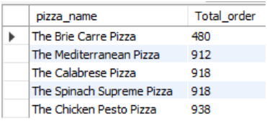

**Note: Using WHERE clause to filter records.**

For example:

SELECT pizza_name, COUNT(DISTINCT order_id) AS Total_Orders

FROM pizza_sales15

WHERE pizza_category = 'Classic'

GROUP BY pizza_name

ORDER BY Total_Orders desc

limit 5;

